**CAPSTONE PROJECT 1**

**Minimum viable Product (MVP)**



Almaz Albanov 040985613

Dominic Beauvais 041026278

Andrew Gaal 04081531

**Use Case Diagram**

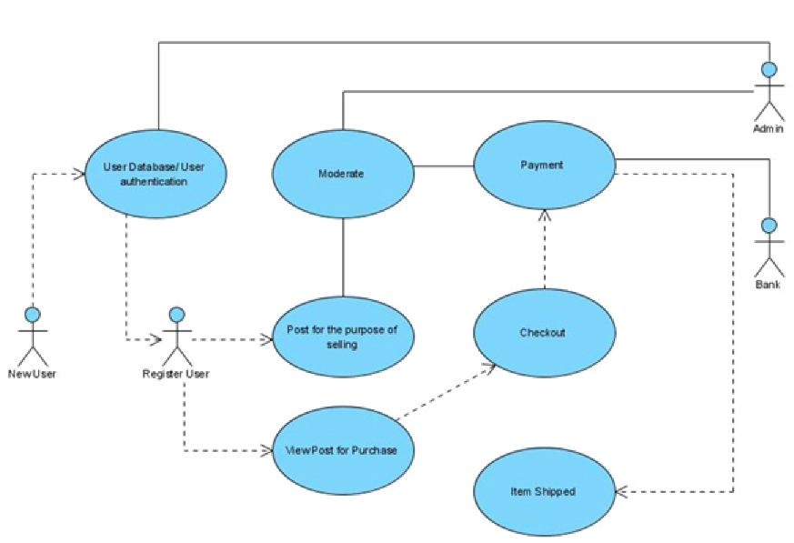

**Class Diagram**

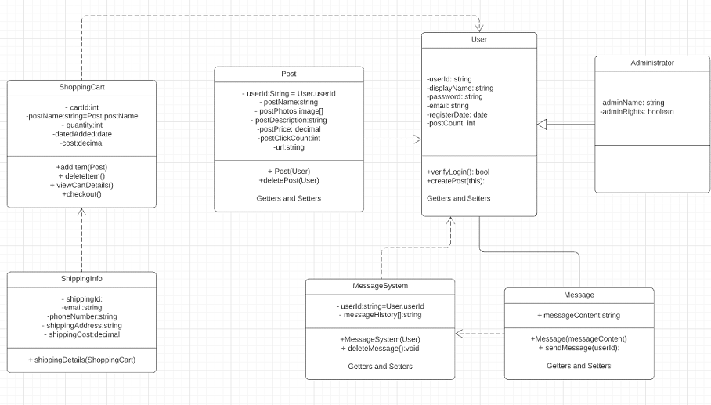

**Sequence Diagram**

